Task 21: Implement a CI/CD pipeline using Jenkins, GitHub Actions, or GitLab CI/CD. Automate code checkout, build, test, and deployment steps, and demonstrate continuous integration and continuous deployment for the application

🎯 Aim
To implement a Continuous Integration and Continuous Deployment (CI/CD) pipeline for a Spring Boot application using Jenkins / GitHub Actions / GitLab CI/CD, automating code checkout, build, testing, and deployment.

🧾 Problem Statement
Manual build, testing, and deployment processes are:
- Time-consuming
- Error-prone
- Not scalable
Hence, we need to:
- Automatically integrate code changes
- Test application continuously
- Deploy application without manual intervention

⚙️ Requirements

🖥️ Software Requirements
- Java 17
- Maven
- Spring Boot
- Git
- GitHub account
- CI/CD Tool:
  - Jenkins OR
  - GitHub Actions (recommended for students)

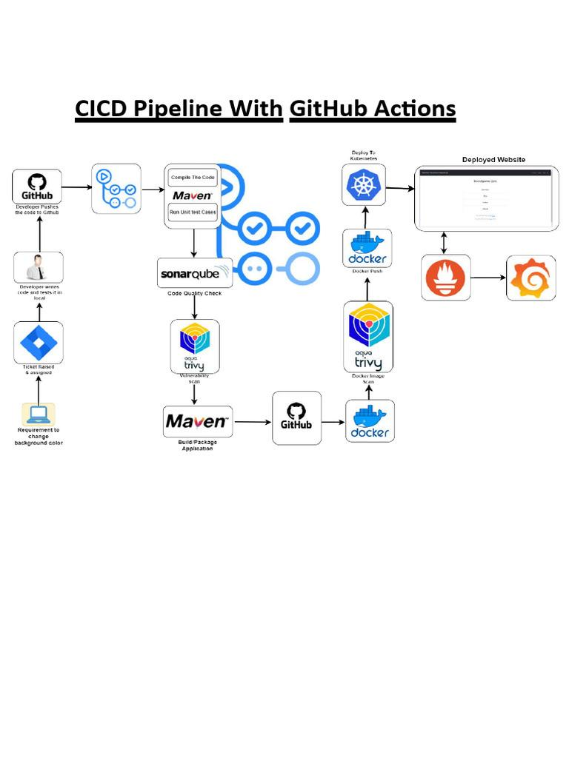

🔄 CI/CD Workflow
- Developer pushes code to GitHub
- Pipeline triggers automatically
- Code is built using Maven
- Tests are executed
- Application is packaged (JAR)
- Deployment is performed

🚀 Implementation using GitHub Actions

📁 Step 1: Create Spring Boot Project (Using STS IDE)

🎯 Objective
To create a basic Spring Boot project with:
- Spring Web
- Spring Boot DevTools
- Proper project structure (src/main/java/controller)

🖥️ Step 1: Open Spring Tool Suite (STS)
Spring Tool Suite
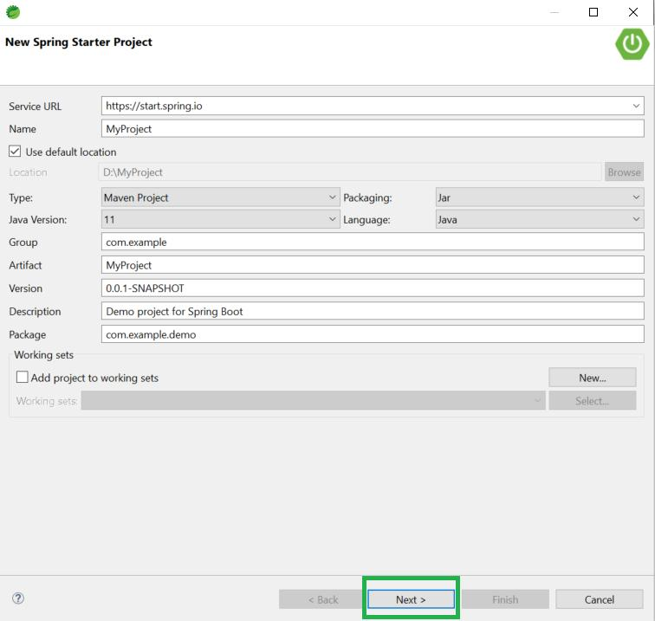
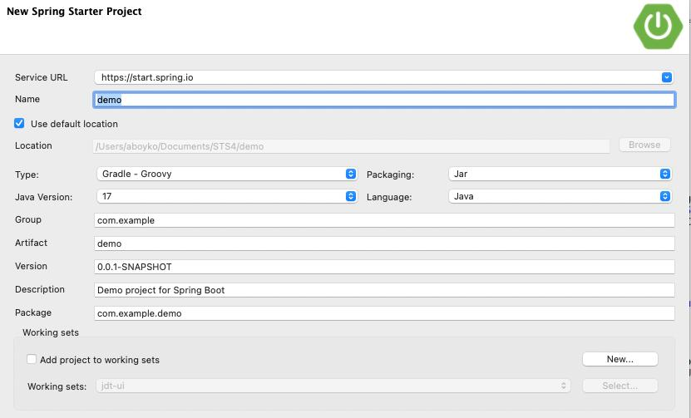
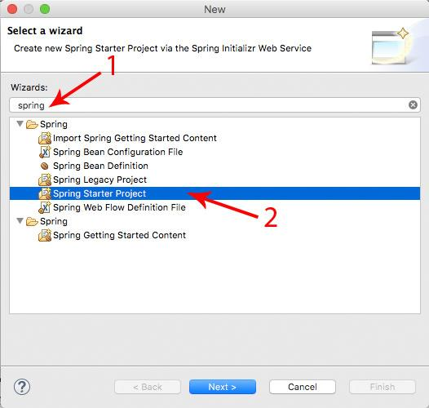
6
👉 Launch STS from your system
👉 Wait until workspace loads completely

📦 Step 2: Create New Spring Starter Project
👉 Follow menu:
File → New → Spring Starter Project

⚙️ Step 3: Configure Project Details
Fill the form carefully:
Field | Value (Example)
Name | demo
Type | Maven
Packaging | Jar
Java Version | 17
Group | com.example
Artifact | demo
Package | com.example.demo
👉 Click Next

📚 Step 4: Add Dependencies
Search and select:
- ✅ Spring Web
- ✅ Spring Boot DevTools
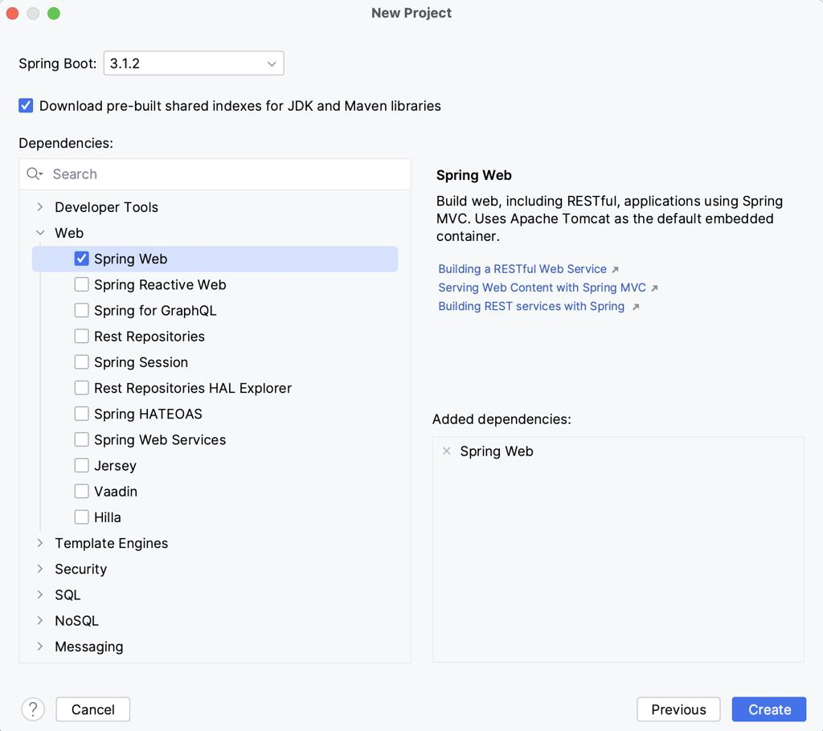
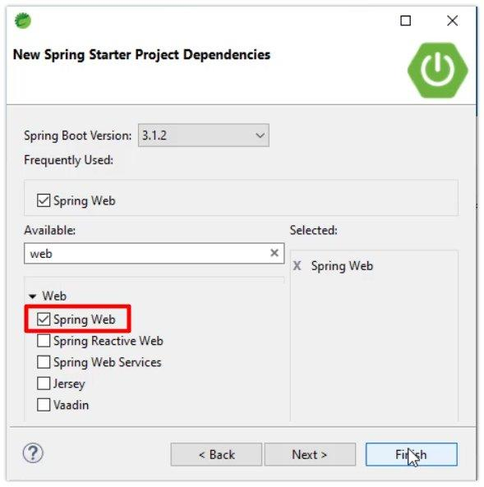
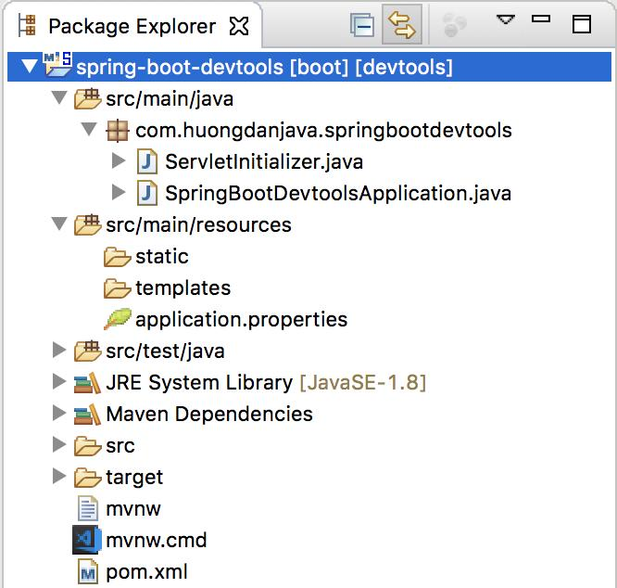
6
👉 Click Finish

⏳ Step 5: Project Creation & Build
- STS will download dependencies (Maven)
- Wait until build completes (bottom console)

📁 Step 6: Verify Project Structure
After creation, your project will look like:
demo
├── src
│ ├── main
│ │ ├── java
│ │ │ └── com.example.demo
│ │ │ └── DemoApplication.java
│ │ └── resources
│ │ ├── application.properties
│ │ └── static / templates
│ └── test
└── pom.xml

📂 Step 7: Create Controller Package
👉 Right-click:
src/main/java → New → Package
👉 Name:
controller

📂 Final Required Structure
src/
└── main/
└── java/
└── controller/
⚠️ (In real projects, better practice is:)
com.example.demo.controller

📄 Step 8: Create Controller Class
👉 Right-click on controller → New → Class
Name:
HelloController

✨ Step 9: Add Sample Code
package com.example.demo.controller;
import org.springframework.web.bind.annotation.GetMapping;
import org.springframework.web.bind.annotation.RestController;
@RestController
public class HelloController {
@GetMapping("/")
public String home() {
return "Spring Boot Project Created Successfully!";
}
}

▶️ Step 10: Run Spring Boot Application
👉 Right-click on:
DemoApplication.java
👉 Click:
Run As → Spring Boot App

🌐 Step 11: Verify Output
Open browser:
http://localhost:8080
👉 Output:
Spring Boot Project Created Successfully!

✅ Output
- Spring Boot project created successfully
- Dependencies installed
- Controller created
- Application running on port 8080

🎯 Result
Spring Boot project with required dependencies and structure is successfully created using STS IDE.

📁 Step 2: GitHub Integration (Push Project)

🎯 Objective
To connect the Spring Boot project with GitHub and push the code repository for CI/CD integration.

⚙️ Prerequisites
- Git installed → Git
- GitHub account
- Spring Boot project already created in STS

🖥️ Step 1: Open Project in STS
👉 Open your project (demo) in
Spring Tool Suite

🔧 Step 2: Initialize Git Repository

👉 Option A: Using Terminal (Recommended)
Open terminal in project folder:
git init
👉 Output:
Initialized empty Git repository

👉 Option B: Using STS GUI
- Right-click project
- Team → Share Project
- Select Git → Finish

📦 Step 3: Add Files to Staging
git add .
👉 Adds all project files to staging area

💬 Step 4: Commit Code
git commit -m "Initial Spring Boot project commit"
👉 Output:
[main (root-commit) xxxx] Initial commit

🌐 Step 5: Create Repository in GitHub
Go to
👉 GitHub

Steps:
- Click New Repository
- Enter name: demo
- Select:
  - Public / Private
- Click Create Repository

🔗 Step 6: Connect Local Project to GitHub
Copy repository URL like:
https://github.com/your-username/demo.git
Run:
git remote add origin https://github.com/your-username/demo.git

🚀 Step 7: Push Code to GitHub
git branch -M main
git push -u origin main
👉 Output:
Enumerating objects...
Counting objects...
Writing objects...

📊 Step 8: Verify in GitHub
- Open your repository
- You should see:
  - src/
  - pom.xml
  - project files

🧾 Expected Repository Structure
demo
├── src/
├── pom.xml
├── .gitignore

⚠️ Important: Add .gitignore
Create file:
.gitignore
Add:
target/
*.log
*.class
👉 Prevents unnecessary files from uploading

🔄 Step 9: Future Updates (Very Important)
Whenever you change code:
git add .
git commit -m "Updated controller"
git push

🖼️ Git Workflow Overview
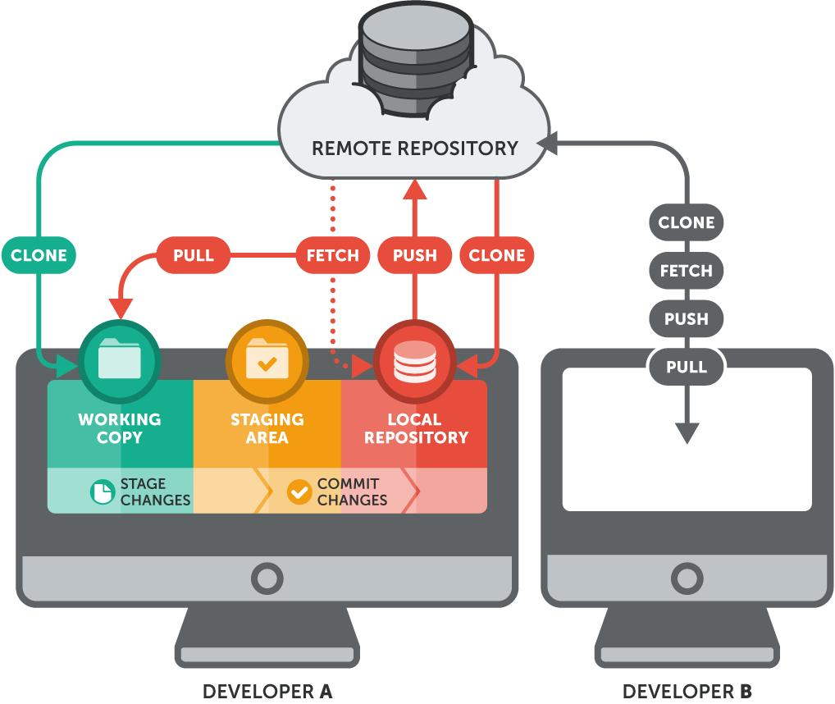

6

📤 Output
- Git repository initialized
- Code committed successfully
- Project pushed to GitHub

✅ Result
Spring Boot project successfully integrated with GitHub and ready for CI/CD pipeline automation.

🚀 Step 3: CI/CD Pipeline using GitHub Actions

🎯 Objective
To automate build, test, and deployment of a Spring Boot project using
GitHub Actions

⚙️ Prerequisites
- Spring Boot project pushed to GitHub
- Maven project (pom.xml)
- Java 17 configured

🧩 Step 1: Create Workflow Folder
Inside your project, create:
.github/workflows/
👉 Final path:
.github/workflows/ci-cd.yml

🧾 Step 2: Write YAML Configuration
Create file:
ci-cd.yml

✨ Complete YAML Code
name: Spring Boot CI/CD Pipeline
on:
push:
branches: [ "main" ]
pull_request:
branches: [ "main" ]
jobs:
build:
runs-on: ubuntu-latest
steps:
- name: Checkout Source Code
uses: actions/checkout@v3
- name: Set up JDK 17
uses: actions/setup-java@v3
with:
distribution: 'temurin'
java-version: '17'
- name: Build with Maven
run: mvn clean install
- name: Run Unit Tests
run: mvn test
- name: Package Application
run: mvn package
- name: Upload Artifact
uses: actions/upload-artifact@v3
with:
name: spring-boot-app
path: target/*.jar
- name: Deploy (Simulated)
run: echo "Application Deployed Successfully!"

🔍 Step 3: Understand YAML (Important for Viva)
Step | Purpose
Checkout | Gets code from GitHub
Setup Java | Installs JDK 17
Build | Compiles project
Test | Runs test cases
Package | Creates JAR file
Upload Artifact | Stores build output
Deploy | Deployment step

🚀 Step 4: Push YAML File to GitHub
git add .
git commit -m "Added CI/CD pipeline"
git push

▶️ Step 5: Pipeline Execution
👉 Go to:
- Repository → Actions Tab
📌 Pipeline runs automatically after push

📊 CI/CD Pipeline Execution Flow
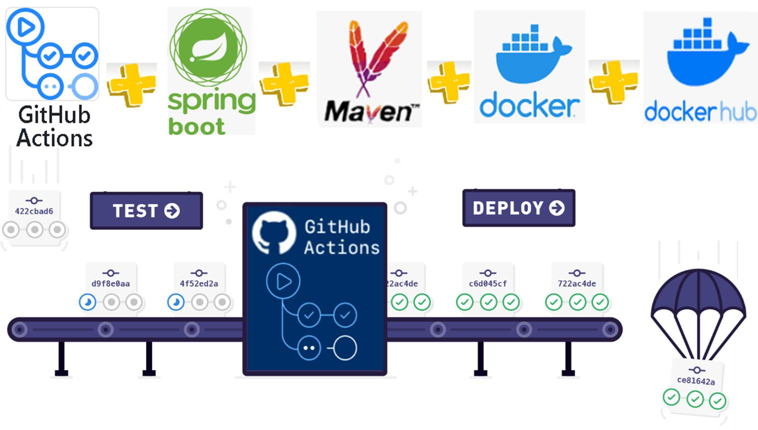
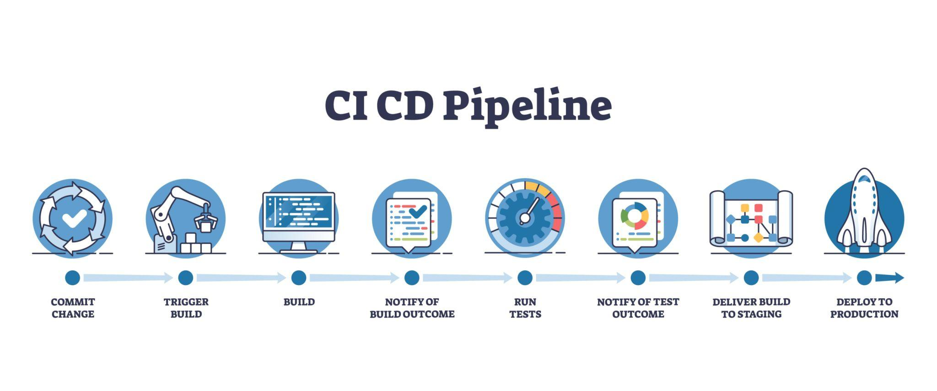
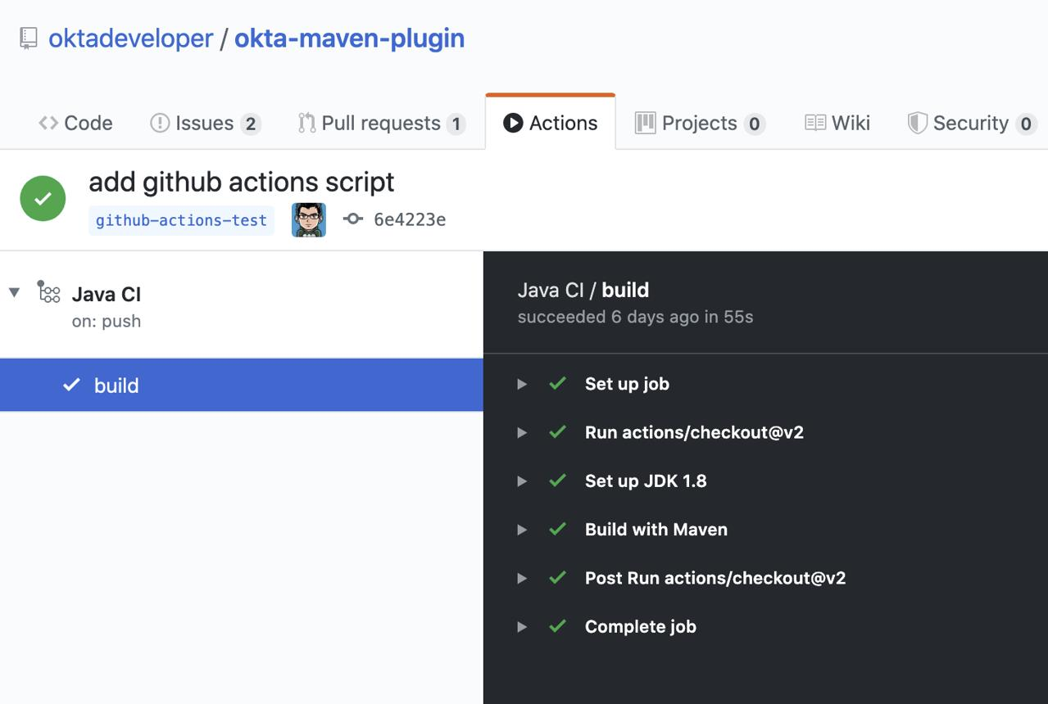
7

📈 Step 6: Verify Execution
You will see:
- ✅ Build → SUCCESS
- ✅ Test → PASSED
- ✅ Package → CREATED
- ✅ Deployment → DONE

📦 Step 7: Download Build Artifact
👉 In GitHub Actions:
- Open workflow run
- Download spring-boot-app (JAR file)

🌐 Step 8: Run Application (Manual Deployment)
Download JAR → Run:
java -jar target/demo-0.0.1-SNAPSHOT.jar
Open:
http://localhost:8080

📤 Output
BUILD SUCCESS
Tests run: SUCCESS
Artifact uploaded
Application Deployed Successfully!

✅ Result
- CI/CD pipeline successfully created
- Code automatically built and tested
- Deployment step executed
- Continuous integration achieved

🎓 Viva Questions & Answers

1. What is CI/CD?
Answer:
CI/CD stands for Continuous Integration and Continuous Deployment. It automates code integration, testing, and deployment.

2. Difference between CI and CD?
CI | CD
Integrates code | Deploys code
Runs tests | Releases app
Frequent commits | Automated delivery

3. What is GitHub Actions?
Answer:
GitHub Actions is a CI/CD tool that automates workflows directly inside GitHub repositories.

4. What is Jenkins?
Answer:
Jenkins is an open-source automation server used for building and deploying applications.

5. What is a pipeline?
Answer:
A pipeline is a sequence of automated steps such as build, test, and deploy.

6. What is Maven?
Answer:
Maven is a build tool used to compile, package, and manage dependencies in Java projects.

7. What triggers a pipeline?
Answer:
Events like:
- Code push
- Pull request
- Scheduled jobs

8. What is YAML?
Answer:
YAML is a configuration language used to define workflows in CI/CD pipelines.

9. What is deployment?
Answer:
Deployment is the process of making an application available to users.

10. Advantages of CI/CD?
- Faster delivery
- Reduced errors
- Automated testing
- Continuous feedback

